Ideation Phase

Brainstorm & Idea Prioritization

Date | 17 February 2026
Team ID | LTVIP2026TMIDS37778
Project Name | Laptop Request Catalog Item

Step-1: Team Gathering, Collaboration and Select the Problem Statement
Our team of four members conducted a collaborative discussion to identify common challenges faced in organizations regarding laptop allocation and asset requests. We observed that manual request handling through emails and spreadsheets leads to delays, lack of transparency, approval confusion, and improper tracking of assets.
After analyzing the feasibility and organizational impact, we selected the following problem statement:
" How might we design and implement a structured Laptop Request Catalog Item in ServiceNow to automate approvals, track requests efficiently, and ensure proper asset management?"

Step-2: Brainstorm, Idea Listing and Grouping
Ideas Generated:
- Create a Laptop Request form in Service Catalog.
- Implement role-based access (Employee, Manager, IT Admin).
- Configure automated approval workflow.
- Enable email notifications for request updates.
- Track request status in real-time.
- Maintain asset allocation records.
- Create SLA tracking for request completion.
- Develop admin dashboard for monitoring requests.
- Generate reports for asset usage and pending approvals.
Grouped Under:
• User Convenience: Easy request submission, status tracking, automated notifications.
• Automation & Control: Approval workflows, SLA tracking, asset record maintenance.
• Monitoring & Reporting: Admin dashboard, performance reports, request analytics.

Step-3: Idea Prioritization

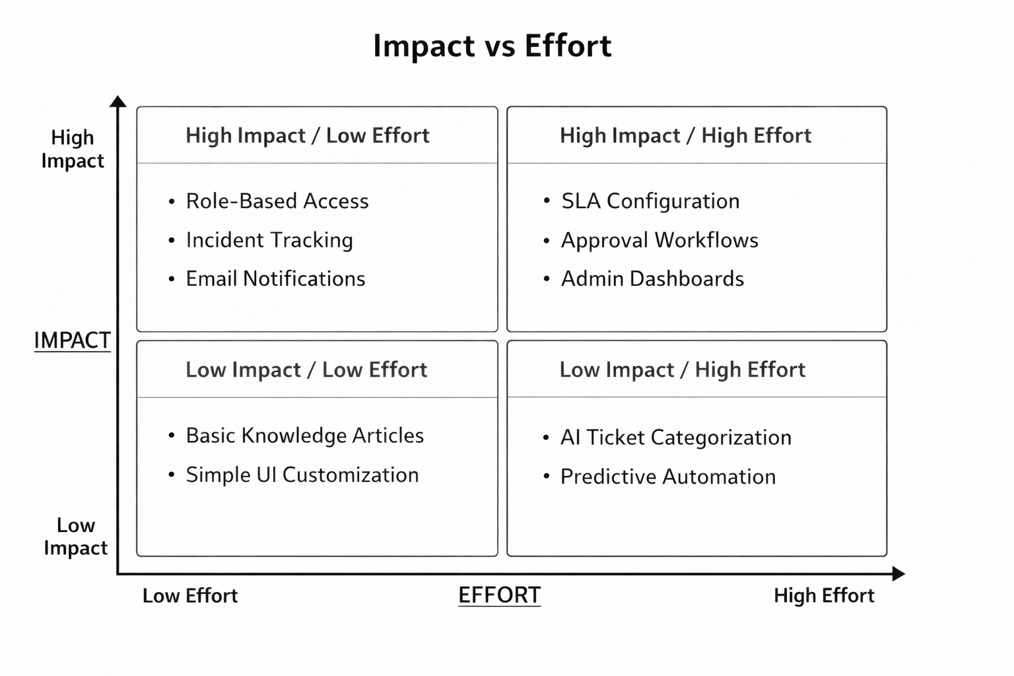

Prioritization Matrix (Impact vs Effort):
High Impact – Low Effort:
• Role-based access configuration
• Basic incident creation & tracking
• Email notifications
High Impact – High Effort:
• SLA configuration
• Automated approval workflows
• Admin dashboards & reporting
Low Impact – Low Effort:
• Basic knowledge articles
• Simple UI customization
Low Impact – High Effort:
• AI-based auto-ticket categorization (Future enhancement)
• Predictive issue resolution using automation

